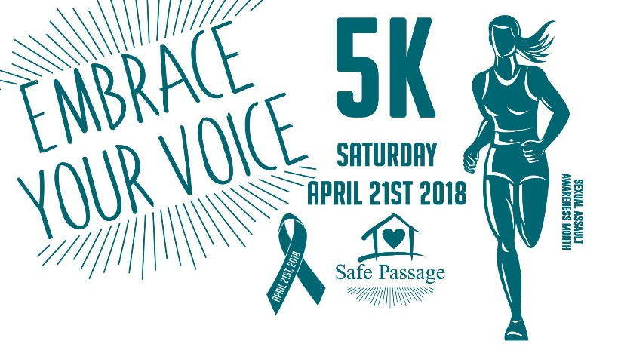
Embrace Your Voice 5K
Saturday, April 21, 2018
Volunteer Form

Dear Volunteer, A successful race requires hours of planning and organization, but one of the most important areas is the support provided by volunteers on race day. If you're interested in volunteering, please fill out the form below. Your volunteer participation will entitle you to receive a race day volunteer shirt along with a Volunteer Pizza Party & Meeting! Thanks so much for supporting this event!

FIRST NAME ___________________________________ LAST NAME ___________________________________________________
PHONE NUMBER___________________________ GROUP VOLUNTEERING WITH__________________________________
E-MAIL ______________________________________________________________________________AGE __________
SIGNATURE _______________________________________________________

SHIRT SIZE ____ Small ____ Med____ Large ____ Xtra-Large ____ 2X____

Which area would you like to provide support? (select all areas of interest)
____ Pre-Race Set Up 7:00am ____ Water/Snack Table 8:00am ____ Start/Finish Line Support 8:45am
____ Packet Pick Up 7:30am ____ Registration 7:30am ____ Half 5K Water Station 9:00am
____ 5k Route Helpers 8:00am ____ Parking (if needed) 5k 7:30am ____ Clean Up Crew 10:00am
____ Wherever needed
Volunteer Pizza Party & Meeting at (Location TBA) Pick up your volunteer shirt, receive important volunteer instructions. I will contact you for time and location of meeting. Please select which day of the week works best for you for the Volunteer Party _____Thursday, April 19th or _____ Friday, April 20th

FOR MORE INFORMATION CONTACT: Melissa Eskew 660-269-8999 or cell 636-395-6738 meskew.sp@gmail.com All Volunteer Forms must be received no later than April 6th 2018 to guarantee a Volunteer T-Shirt! Please email meskew.sp@gmail.com or mail signed form to: Safe Passage, PO Box 456, Moberly MO 65270

